

**University Institute of Information Technology,**

**PMAS-Arid Agriculture University,**

**Rawalpindi Pakistan**

**Trading Track**

***By***

**Muhammad Bilal 19-ARID-824**

**Haris Mehboob 19-ARID-802**

***Supervisor*Mr. Suleman Khurram**

**Chapter 3: Requirement Analysis**

In this Chapter we will define all the requirements of our proposed system that includes functional and non- functional requirements. We also have mentioned the use cases of the system and how our system will respond to various use cases.

# Use Cases

**Use Case Diagram:**

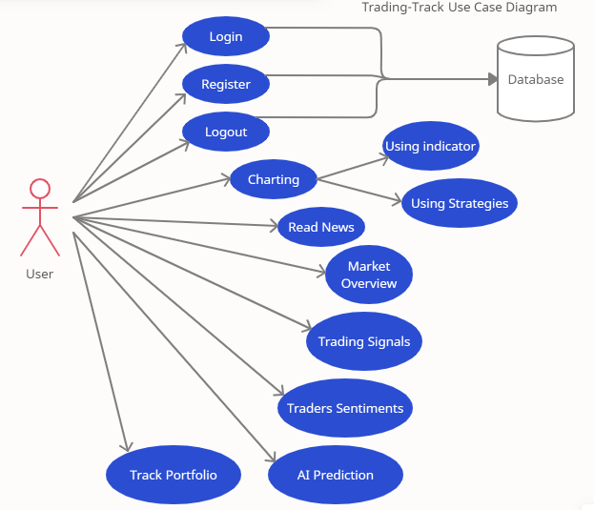

**Figure 3.1**

# Use Case Description

|  |  |
| --- | --- |
| **Use Case ID:** | ID-01 |
| **Use Case Name:** | Authentication |
| **Actors:** | User, System |
| **Description:** | User will provide his credentials and authenticated by the system through database. |
| **The rigger:** | When user clicks the login button. |
| **Preconditions:** | Username and password must be provided by the user. |
| **Log in** | User will login successfully. |
| **Normal Flow:** | Credentials will be entered by users.  Credentials will be authenticated from database of the system. User will be successfully logged in. |
| **Alternative Flows:** | If user is not already registered, then user will first sign up User will then provide credentials  User will again be authenticated through database |
| **Exceptions:** | If user is not authenticated, error message will be appeared. |
| **Special**  **Requirements:** | None |
| **Assumptions:** | None |
| **Notes and Issues:** | User will have only 3 attempts for login. After 3 attempts user will have to wait for  30 seconds to retry. |

|  |  |
| --- | --- |
| **Use Case ID:** | ID-02 |
| **Use Case Name:** | Market Overview |
| **Actors:** | User, System |
| **Description:** | System will show different available currencies in the market.  User will select any of the currency according to his own choice. |
| **Trigger:** | When user clicks any currency. |
|  | Preconditions: User should be authenticated. |
| **Preconditions:** | User should be authenticated.  User should have internet connection. |
| **Post conditions:** | The system will provide available currencies to the buyer. |
| **Normal Flow:** | User will first login into the web app, then he/she will select any currency according to his/her choice. |
| **Alternative Flows:** | None. |
| **Exceptions:** | If user does not select any currency from the overview, he will just be looking at the market overview. |
| **Special**  **Requirements:** | None. |
| **Assumptions:** | None. |
| **Notes and Issues:** | If User specifically wants to look at the details of a currency, he/she must click it. |

|  |  |
| --- | --- |
| **Use Case ID:** | ID-03 |
| **Use Case Name:** | News Flow |
| **Actors:** | User, System |
| **Description:** | System will show currency related news.  User will select any of the news according to his/her own choice. |
| **Trigger:** | When User clicks on any news. |
| **Preconditions:** | User should be authenticated.  User should have internet connection. |
| **Post conditions:** | The system will provide flow of news. |
| **Normal Flow:** | User will first login into the web app, then he/she will select any news according to his/her own choice. |
| **Alternative Flows:** | None |
| **Exceptions:** | If user does not select any news from the overview, he will just be looking at the News Flow. |

|  |  |
| --- | --- |
| **Special**  **Requirements:** | None |
| **Assumptions:** | None |
| **Notes and Issues:** | If User specifically wants to look at the details of any news, he/she must click it. |

|  |  |
| --- | --- |
| **Use Case ID:** | ID-04 |
| **Use Case Name:** | Sentimental Analysis |
| **Actors:** | Users, System |
| **Description:** | A user who is looking for professional help from a trading expert can get help from the Sentimental Analysis section.  Trading Experts leave their reviews on whether a specific currency should be bought or not. |
| **Trigger:** | When User clicks the Sentimental Analysis Section. |
| **Preconditions:** | User should be authenticated.  User should have internet connection. |
| **Post conditions:** | The user will be able to look at the reviews of trading experts on any currency in the form of Buy, Sell and Neutral signals. |
| **Normal Flow:** | User will first login into the web app, and then he will select the sentimental analysis section.  This section will show the signals of trading experts in the form of Buy, Sell and Neutral signals to help the user take a decision for a trade or general news. |
| **Alternative**  **Flows:** | None |
| **Exceptions:** | If User does not select any specific currency in the Sentimental Analysis section, he/she will just be continuously looking at the signals from trading experts on a specific currency. |
| **Special**  **Requirements:** | None |
| **Assumptions:** | None |
| **Notes and Issues:** | The User should select a specific currency of his/her own choice to look at the Sentimental Analysis of that currency. |

|  |  |
| --- | --- |
| **Use Case ID:** | ID-05 |
| **Use Case Name:** | Technical Analysis |
| **Actors:** | Users, System |
| **Description:** | User can look at the Technical Analysis of any currency of their own choice.  In this section, an analysis is done using charting patterns and indications to give a prediction to help user buy, sell or stay humble about that currency at that time. |
| **Trigger:** | When Users clicks the Technical Analysis Section. |
| **Preconditions:** | User should be authenticated.  User should have internet connection. |
| **Post conditions:** | The user will be able to look at Technical analysis on any currency in the form of Buy, Sell and Neutral signals. |
| **Normal Flow:** | User will first login into the web app, and then he will select the technical analysis section.  This section will show the technical analysis of currencies in the form of Buy, Sell and Neutral signals to help the user take a decision for a trade or general news. |
| **Alternative**  **Flows:** | None |
| **Exceptions:** | If User does not select any specific currency in the Technical Analysis section, he/she will just be continuously looking at the technical analysis on a specific currency. |
| **Special**  **Requirements:** | None |
| **Assumptions:** | None |
| **Notes and Issues:** | The User should select a specific currency of his/her own choice to look at the Technical Analysis of that currency. |

|  |  |
| --- | --- |
| **Use Case ID:** | ID-06 |
| **Use Case Name:** | AI Prediction |
| **Actors:** | User, System |
| **Description:** | User can see the Opening Prediction of currencies and check whether they are high or low.  AI Prediction uses historical data to predict it. |

|  |  |
| --- | --- |
| **Trigger:** | When User clicks the AI Prediction section. |
| **Preconditions:** | User should be authenticated.  User should have internet connection. |
| **Post conditions:** | The User will be able to look at the opening prediction of any currency of his/her own choice. |
| **Normal Flow:** | User will first login into the web app, click the AI Prediction section. Look at the opening prediction of any currency of his/her own choice. |
| **Alternative Flows:** | None |
| **Exceptions:** | If user does not select any currency of his/her own choice, they will keep looking at the same opening predictions about the same currency. |
| **Special Requirements:** | None |
| **Assumptions:** | None |
| **Notes and Issues:** | The user should select a currency of his/her own choice to see the opening prediction about that currency. |

**Functional requirements**

The system allows user to search the currency pairs

The system allows user to select a specific currency pair.

The system allows user to register himself.

The system allows user to keep track of his trades(portfolio).

The system allows user to browse the charts

The system will use AI techniques and show prediction of stocks to the user

The user will be able to share feedback

**Non-Functional Requirements**

The system will be able to handle the concurrent requests from different users.

The system will provide confidentiality for user data.

The system will be stable and reliable enough to handle the exceptions.

The system will be available for 24/7 of the time to handle the concurrent request of the user.

The system will be efficient enough to handle the concurrent request to the user.

Interface and the system itself should be buyer friendly so that the product seeker will feel it easy to use.